One Good Project Euler Problem .

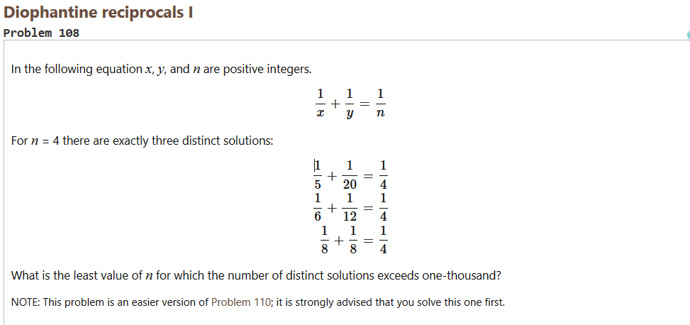

So I solved it this way,

$x, y both must be greater than n for the given equation to hold true since \frac{1}{x}≥\frac{1}{n} ∀x≤n. Thus if any of x or y is less than n then the value has to be greater than n.$

$Now the equation can be written as \frac{ 1}{n+a}+\frac{1}{n+b}=\frac{1}{n}. Solving this we get n^{2}=a.b.$

$$Since a.b is a number ultimately and for distinct values of a, b which would imply value of n+a, n+b ≡x,y should be different.Now any number for e.g. let^{'}s take 12.$$

$$12=1*12 12=2*6 12=3*4 .$$

$Now the repetition starts like 12=4*3 12=6*2 and 12=12*1.$

$$Therefore if we take the \left[\sqrt{12}\right] where \left[.\right] denotes the floor function. Similarly in our case we$$

$need to compute the divisors of n^{2} which are less than or equal to. These would be$

$$half of the total number of divisors of n^{2}. So we get an equation\frac{d\left(n^{2}\right)}{2}>1000 or d\left(n^{2}\right)>2000 where I{}_{}^{'}musing d\left(x\right) as number of divisors of x.Beware:divisors of n^{2} are$$

$different from that of n.$

$$n^{2}{=p_{1 }}^{2k_{1}}{p_{2 }}^{{2k}_{2}}{p_{3 }}^{2k_{3}}{p_{4 }}^{2k_{4}}…………. for primes p_{1 }, p_{2 },p_{3 , }p_{4 }… and the number of$$

$$divisors of{ n}^{2} is given by this formula:$$

$$\left(2k_{1 }+1\right)\left(2k_{2 }+1\right)\left(2k_{3 }+1\right)\left(2k_{4 }+1\right)……$$

$Now we have to minimize the product such that the number of divisors are atleast 2000.$

$$The number of divisors will be proportional to the number of brackets in the formula and$$

$also proportional to the powers of the primes \left(k_{1, }k_{2},k_{3}…….\right).$

$So let us as assume n^{2}has prime decomposition as 2^{2}*3^{2}*5^{2}*7^{2}*{11}^{2}*{13}^{2}* {17}^{2}. Now what are the number of divisors of n^{2} in this case.It would simply be$

$$\left(2*1 + 1\right)\left(2*1 + 1\right)\left(2*1 + 1\right)\left(2*1 + 1\right)\left(2*1 + 1\right)\left(2*1 + 1\right)\left(2*1 + 1\right)=3^{7}=2187 and thus the fewest number of required primes for number of divisors to be greater$$

$than 2000 is 7.But as suggested above that it^{'}s two factors that we have to see.$

$Thus we can do better and minimize our number. Start by removing {17}^{2} .$

$Now our "\text{new" }n^{2} has less than 2000 divisors Now we should consider increasing the powers.$

$$since they can reduce our number n^{2}. Now to do so consider the following approach.$$

$$Try multiplying n^{2} by all squares from 2^{2} to {16}^{2} keeping in find that you need the least$$

$$number which would make the number of divisors greater than 2000. If you multiple by 2^{2} the$$

$$number of divisors will become 3^{5}*5= 1215 which is less than 2000.$$

$$Try 3^{2} now which would again give 1215 divisors.Infact for any prime selected it would give$$

$the same number of divisors.So just use the composite numbers. Trying with 4^{2} will$

$give 3^{5}*7=1701 remainders, leaving 5^{2} as discussed previously,choose 6^{2}or$

$3^{2}2^{2} which would give number of divisors as 3^{4}*5^{2}= 2025 which is greater than 2000.$

$Voila!We completed iteration 1. Now new value of n^{2} is 2^{4}*3^{4}*5^{2}*7^{2}*{11}^{2}*{13}^{2}.$

$Now do the same by cancelling {13}^{2}.Fortunately we wouldn^{'}t find any number smaller than {13}^{2}$

$which can be replaced giving number of divisors>2000. Thus, we stop since we have$

$reached the smallest number. Thus the answer is \sqrt{2^{4}*3^{4}*5^{2}*7^{2}*{11}^{2}*{13}^{2}} =180180$